**Day 3 – E-Mail Service**

1. Research the following internet protocols related to e-mail services.
   1. SMTP Protocol
   2. POP3 Protocol
   3. IMAP Protocol
   4. Web Mail
2. Use the following resource as a starting point:  
   <https://askleo.com/what_is_pop_or_pop3_or_a_pop_account_and_what_about_smtp/>
3. 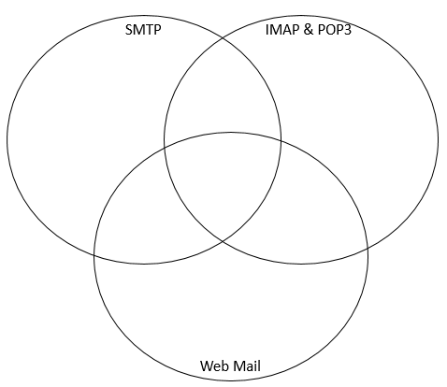Complete the following Venn Diagram to summarize your research.

Allows your PC to send mail

All mail stays on server

Server provides a dynamic website that you access through a web browser

Allows PC to read mail

POP (post office protocol) is the language used between a computer fetching email (email program) and the computer which is holding the email (emails service provider